FFT filtering on CO2 sensor

# Given:

1. Sampled data, sampling period : 160ms

# Some notes:

1. First checked with MATLAB.
2. Implemented in C to add in the existing project
3. Given sampled data for active and reference channel are plotted for a single period (250 sampled data) as:

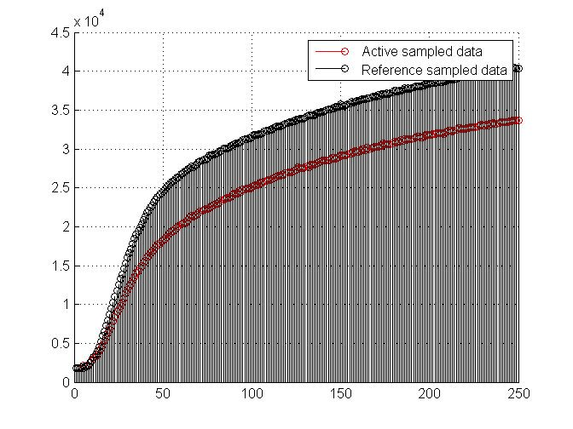

1. With help of Discrete Fourier Transform, frequency spectrum was calculated. FFT is used to analyze the frequency spectrum and some portion of active and reference channel frequency spectrum are shown as :

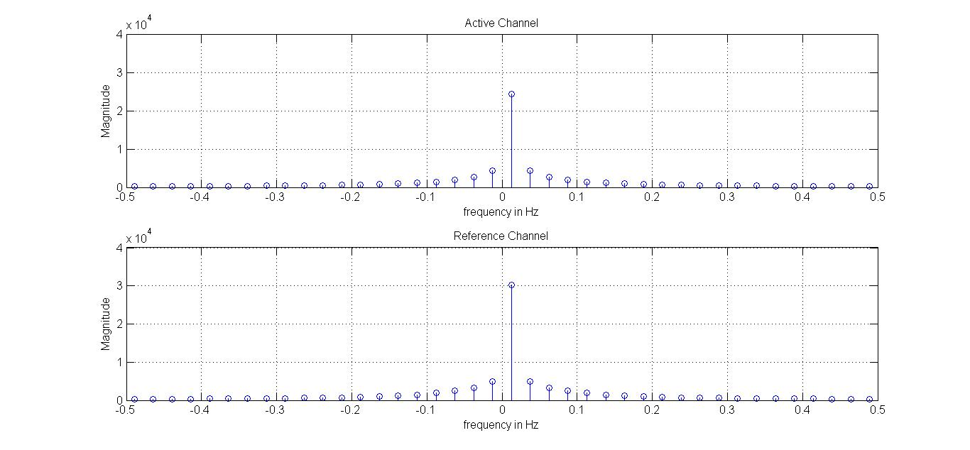

1. Found the maximum amplitude ‘return value’ in active channel as shown below:

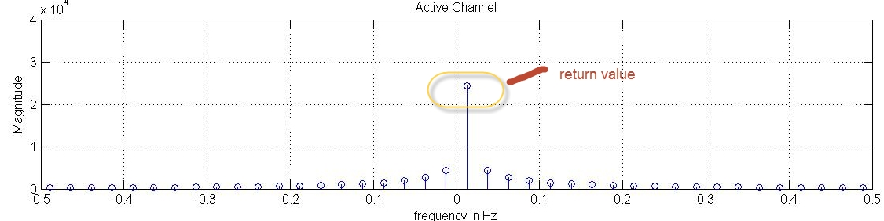

# Some notes on MATLAB Coding:

1. Use of matlab built in function -🡪 fft
2. Returns ‘return value’ as a maximum value in form of output of FFT_CO2 function

# Some notes on C coding:

1. C code has been developed using ‘MATLAB CODER’
2. The function ‘FFT_CO2.c’ takes 250*1 double data as input and produces a single double value as output.
3. Input big data is always fixed length (250*1, double) for example :

active_data= [1849

1757

1845

1960

2103

2075

2135

2165

2412

2666

2985

3299

3589

3948

4328

4778

5313

5761

6285

6719

7186

7812

8392

8997

9381

9846

10268

10835

11421

11848

12313

12597

13073

13493

14114

14335

14694

14975

15398

15654

16030

16258

16627

16845

17036

17396

17715

17846

18090

18272

18398

18722

19017

19161

19390

19464

19675

19881

20132

20349

20454

20527

20583

20808

21165

21450

21294

21441

21519

21683

21913

22036

22188

22269

22295

22425

22655

22770

22883

22937

22941

23155

23377

23494

23595

23662

23658

23845

23989

24252

24245

24302

24533

24505

24751

24758

24863

24879

24902

25096

25265

25354

25350

25491

25628

25662

25804

25889

26024

25984

26088

26185

26305

26469

26530

26562

26632

26706

26838

27000

27033

27003

27071

27188

27263

27633

27511

27518

27560

27667

27747

27689

27952

27941

27930

28041

28206

28305

28368

28490

28481

28539

28566

28668

28867

28807

28784

28870

28995

29221

29187

29180

29177

29260

29358

29400

29563

29732

29602

29664

29740

29939

29919

29879

30127

29982

30086

30181

30310

30308

30256

30376

30414

30699

30626

30629

30617

30563

30728

30964

30818

30917

30919

31109

31063

31229

31199

31224

31208

31209

31340

31450

31614

31542

31504

31462

31612

31758

31759

31825

31794

31889

31908

31976

32060

32053

32019

31962

32165

32238

32330

32366

32296

32365

32413

32649

32638

32581

32574

32592

32661

32715

32794

32827

32840

32748

32891

33046

33122

32996

32991

33086

33056

33234

33273

33304

33262

33233

33326

33429

33442

33464

33423

33397

33520

33577

33720

33635

33671

33666

];